15.6: Comparison with Eq. (15.4) gives a)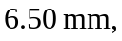 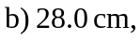 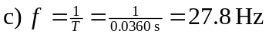 and from Eq. (15.1), d)  